Name: Sibghatullah roll no: 24p-0039
Bcs-4b

Q1:
#include<iostream>
using namespace std;

class Node{
public:
int rollNumber;
string name;
string department;
Node* next;

Node(int rollNumber, string name, string department){
this -> rollNumber = rollNumber;
this -> name = name;
this -> department = department;
this -> next = NULL;
}
};

void addStudent(Node* &head, int rollNumber, string name, string department){
Node* temp = new Node(rollNumber, name, department);
if(head == NULL){
head = temp;
return;
}

Node* n = head;
while(n -> next != NULL){
n = n -> next;
}

n -> next = temp;
}

void deleteStudent(Node* &head, int rollNumber){
if(head == NULL){
return;
}

if(head -> rollNumber == rollNumber){
Node* temp = head;
head = head -> next;
delete temp;
return;
}

Node* curr = head;
Node* prev = NULL;

while(curr != NULL && curr -> rollNumber != rollNumber){
prev = curr;
curr = curr -> next;
}

if(curr == NULL){
cout<<"Student with roll number "<<rollNumber<<" not found"<<endl;
return;
}

prev -> next = curr -> next;
delete curr;
}

void print(Node* head){
if(head == NULL){
cout<<"No students registered"<<endl;
return;
}

Node* temp = head;
while(temp != NULL){
cout<<"Roll Number: "<<temp -> rollNumber<<" Name: "<<temp -> name<<" Department: "<<temp -> department<<endl;
temp = temp -> next;
}
}

int main(){
Node* head = NULL;

addStudent(head, 101, "sibhat", "Computer Science");
addStudent(head, 102, "muneer", "Electrical Engineering");
addStudent(head, 103, "ali noor", "Mechanical Engineering");
addStudent(head, 104, "Dev", "Civil Engineering");

print(head);

cout<<endl;
deleteStudent(head, 102);
deleteStudent(head, 999);

cout<<endl;
print(head);
}

OUTPUT:
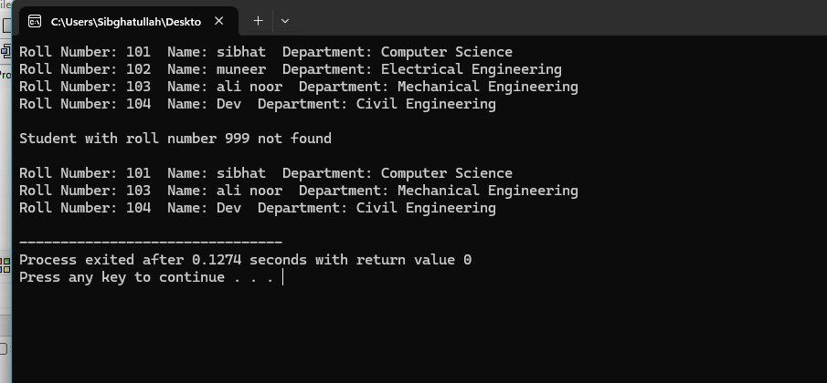

Q2:
#include<iostream>
using namespace std;

class Node{
public:
int bookID;
string title;
string author;
Node* next;

Node(int bookID, string title, string author){
this -> bookID = bookID;
this -> title = title;
this -> author = author;
this -> next = NULL;
}
};

void insertAtStart(Node* &head, int bookID, string title, string author){
Node* temp = new Node(bookID, title, author);
temp -> next = head;
head = temp;
}

void insertAtEnd(Node* &head, int bookID, string title, string author){
Node* temp = new Node(bookID, title, author);
if(head == NULL){
head = temp;
return;
}

Node* n = head;
while(n -> next != NULL){
n = n -> next;
}

n -> next = temp;
}

void insertAtPosition(Node* &head, int bookID, string title, string author, int pos){
if(pos == 0){
insertAtStart(head, bookID, title, author);
return;
}

Node* temp = new Node(bookID, title, author);
Node* curr = head;
Node* prev = NULL;

for(int i = 0 ; i < pos && curr != NULL ; i++){
prev = curr;
curr = curr -> next;
}

if(prev != NULL){
prev -> next = temp;
temp -> next = curr;
}
}

void deleteAtStart(Node* &head){
if(head == NULL){
cout<<"No books available"<<endl;
return;
}
Node* temp = head;
head = head -> next;
delete temp;
}

void deleteAtEnd(Node* &head){
if(head == NULL){
cout<<"No books available"<<endl;
return;
}

if(head -> next == NULL){
delete head;
head = NULL;
return;
}

Node* curr = head;
Node* prev = NULL;

while(curr -> next != NULL){
prev = curr;
curr = curr -> next;
}

prev -> next = NULL;
delete curr;
}

void deleteAtPosition(Node* &head, int pos){
if(head == NULL){
cout<<"No books available"<<endl;
return;
}

if(pos == 0){
deleteAtStart(head);
return;
}

Node* curr = head;
Node* prev = NULL;

for(int i = 0 ; i < pos && curr != NULL ; i++){
prev = curr;
curr = curr -> next;
}

if(curr == NULL){
cout<<"Position out of range"<<endl;
return;
}

prev -> next = curr -> next;
delete curr;
}

void searchBook(Node* head, int bookID){
if(head == NULL){
cout<<"No books available"<<endl;
return;
}

Node* curr = head;
while(curr != NULL){
if(curr -> bookID == bookID){
cout<<"Book Found:"<<endl;
cout<<"Book ID: "<<curr -> bookID<<" Title: "<<curr -> title<<" Author: "<<curr -> author<<endl;
return;
}
curr = curr -> next;
}

cout<<"Book with ID "<<bookID<<" not found"<<endl;
}

void print(Node* head){
if(head == NULL){
cout<<"No books available"<<endl;
return;
}

Node* temp = head;
while(temp != NULL){
cout<<"Book ID: "<<temp -> bookID<<" Title: "<<temp -> title<<" Author: "<<temp -> author<<endl;
temp = temp -> next;
}
}

int main(){
Node* head = NULL;

insertAtEnd(head, 103, "Aag Ka Darya", "Qurratulain Hyder");
insertAtEnd(head, 104, "Khuda Aur Mohabbat", "Hashim Nadeem");
insertAtEnd(head, 105, "Raja Gidh", "Bano Qudsia");

cout<<"after insert at end"<<endl;
print(head);

insertAtStart(head, 101, "Udas Naslain", "Abdullah Hussein");
insertAtStart(head, 100, "Meri Kahani", "Zulfiqar Ali Bhutto");

cout<<endl<<"after insert at start"<<endl;
print(head);

insertAtPosition(head, 102, "Andhera Ujala", "Ashfaq Ahmed", 2);

cout<<"after insert at position 2"<<endl;
print(head);

deleteAtStart(head);

cout<<"after insert at start"<<endl;
print(head);

deleteAtEnd(head);

cout<<"after insert at end"<<endl;
print(head);

deleteAtPosition(head, 2);

cout<<"after delte at position 2"<<endl;
print(head);

cout<<"search for book id 103-"<<endl;
searchBook(head, 103);

cout<<"search for book id 999"<<endl;
searchBook(head, 999);
}
Output:
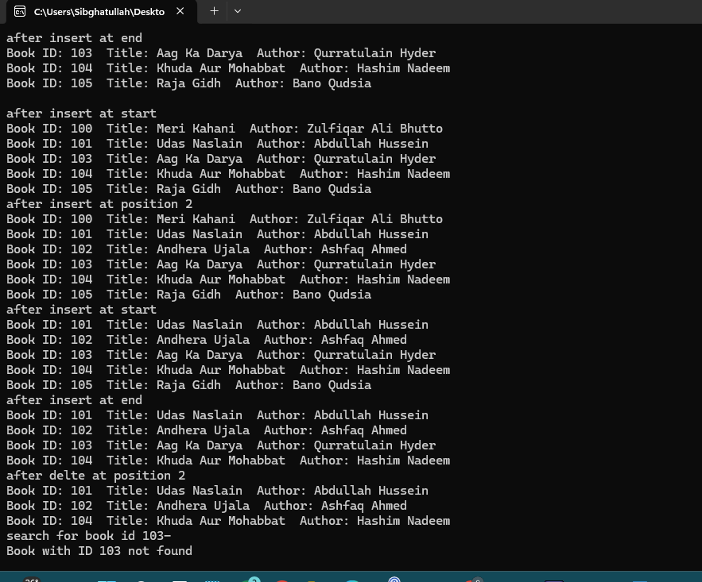

Q3:
#include<iostream>
using namespace std;

class Node{
public:
int data;
Node* next;

Node(int data){
this -> data = data;
this -> next = NULL;
}
};

void insertAtEnd(Node* &head, int val){
Node* temp = new Node(val);
if(head == NULL){
head = temp;
return;
}

Node* n = head;
while(n -> next != NULL){
n = n -> next;
}

n -> next = temp;
}

void segregateEvenOdd(Node* &head){
if(head == NULL){
return;
}

Node* evenHead = NULL;
Node* evenTail = NULL;
Node* oddHead = NULL;
Node* oddTail = NULL;

Node* curr = head;

while(curr != NULL){
if(curr -> data % 2 == 0){
if(evenHead == NULL){
evenHead = curr;
evenTail = curr;
} else {
evenTail -> next = curr;
evenTail = curr;
}
} else {
if(oddHead == NULL){
oddHead = curr;
oddTail = curr;
} else {
oddTail -> next = curr;
oddTail = curr;
}
}
curr = curr -> next;
}

if(evenHead == NULL || oddHead == NULL){
return;
}

evenTail -> next = oddHead;
oddTail -> next = NULL;
head = evenHead;
}

void print(Node* head){
if(head == NULL){
cout<<"List is empty"<<endl;
return;
}

Node* temp = head;
while(temp != NULL){
cout<<temp -> data;
if(temp -> next != NULL){
cout<<" -> ";
}
temp = temp -> next;
}
cout<<" -> NULL"<<endl;
}

int main(){
Node* head = NULL;

int n, val;
cout<<"Enter number of elements: ";
cin >> n;

cout<<"Enter elements: ";
for(int i = 0 ; i < n ; i++){
cin >> val;
insertAtEnd(head, val);
}

cout<<"\nInput: ";
print(head);

segregateEvenOdd(head);

cout<<"Output: ";
print(head);

cout<<endl<<"Addtional test cases"<<endl;

Node* head2 = NULL;
insertAtEnd(head2, 17);
insertAtEnd(head2, 15);
insertAtEnd(head2, 8);
insertAtEnd(head2, 12);
insertAtEnd(head2, 10);
insertAtEnd(head2, 5);
insertAtEnd(head2, 4);
insertAtEnd(head2, 1);
insertAtEnd(head2, 7);
insertAtEnd(head2, 6);

cout<<"\nInput: ";
print(head2);
segregateEvenOdd(head2);
cout<<"Output: ";
print(head2);

Node* head3 = NULL;
insertAtEnd(head3, 8);
insertAtEnd(head3, 12);
insertAtEnd(head3, 10);

cout<<"\nInput: ";
print(head3);
segregateEvenOdd(head3);
cout<<"Output: ";
print(head3);

Node* head4 = NULL;
insertAtEnd(head4, 1);
insertAtEnd(head4, 3);
insertAtEnd(head4, 5);
insertAtEnd(head4, 7);

cout<<"\nInput: ";
print(head4);
segregateEvenOdd(head4);
cout<<"Output: ";
print(head4);
}
Ouput:
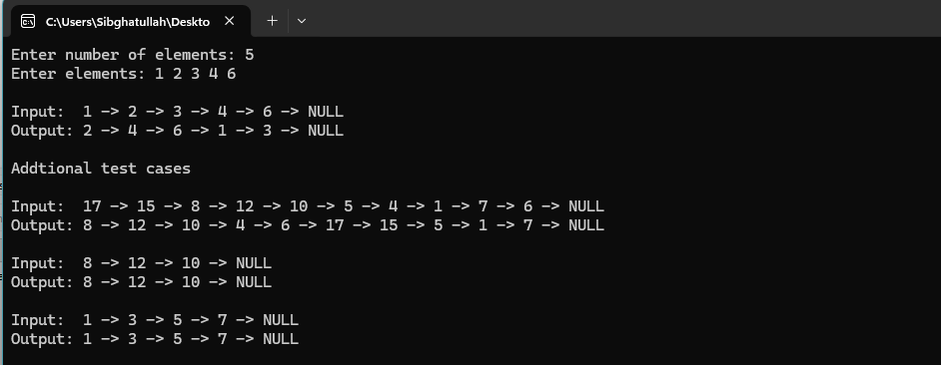

Q4:
#include<iostream>
#include<string>
using namespace std;

class Node{
public:
char data;
Node* next;

Node(char data){
this -> data = data;
this -> next = NULL;
}
};

void insertAtEnd(Node* &head, char ch){
Node* temp = new Node(ch);
if(head == NULL){
head = temp;
return;
}

Node* n = head;
while(n -> next != NULL){
n = n -> next;
}

n -> next = temp;
}

void buildList(Node* &head, string word){
for(int i = 0 ; i < word.length() ; i++){
insertAtEnd(head, word[i]);
}
}

int getLength(Node* head){
int count = 0;
Node* temp = head;
while(temp != NULL){
count++;
temp = temp -> next;
}
return count;
}

Node* reverseList(Node* head){
Node* prev = NULL;
Node* curr = head;
Node* next = NULL;

while(curr != NULL){
next = curr -> next;
curr -> next = prev;
prev = curr;
curr = next;
}

return prev;
}

bool checkPalindrome(Node* head){
if(head == NULL || head -> next == NULL){
return true;
}

int len = getLength(head);
int mid = len / 2;

Node* curr = head;
for(int i = 0 ; i < mid ; i++){
curr = curr -> next;
}

if(len % 2 != 0){
curr = curr -> next;
}

Node* secondHalf = reverseList(curr);
Node* firstHalf = head;
Node* temp = secondHalf;

bool isPalindrome = true;

while(temp != NULL){
if(firstHalf -> data != temp -> data){
isPalindrome = false;
break;
}
firstHalf = firstHalf -> next;
temp = temp -> next;
}

reverseList(secondHalf);

return isPalindrome;
}

void print(Node* head){
Node* temp = head;
while(temp != NULL){
cout<<temp -> data;
if(temp -> next != NULL){
cout<<" -> ";
}
temp = temp -> next;
}
cout<<" -> NULL"<<endl;
}

int main(){
string word;
cout<<"Hamza (Text Editor Developer) - Palindrome Checker"<<endl;
cout<<"Enter a word to check: ";
cin >> word;

Node* head = NULL;
buildList(head, word);

cout<<"\nLinked List: ";
print(head);

if(checkPalindrome(head)){
cout<<"Palindrome: true"<<endl;
} else {
cout<<"Palindrome: false"<<endl;
}

cout<<"test cases"<<endl;

string testWords[] = {"Shan", "Tapal", "Gul", "Haleeb", "civic", "Engro", "aja", "Noon", "Pakola", "ana"};
string testedBy[] = {"Bilal", "Zara", "Usman", "Fatima", "Hamza", "Ayesha", "Tariq", "Sana", "Ali", "Hina"};

for(int i = 0 ; i < 10 ; i++){
Node* testHead = NULL;
buildList(testHead, testWords[i]);
cout<<"\nTested By : "<<testedBy[i]<<endl;
cout<<"Word : "<<testWords[i]<<endl;
cout<<"Linked List: ";
print(testHead);
if(checkPalindrome(testHead)){
cout<<"Palindrome: true"<<endl;
} else {
cout<<"Palindrome: false"<<endl;
}
}
}
Output:
